Jobs & Pipelines

**Job Creation**

**Scheduled Trigger**

**File Arrival Trigger**

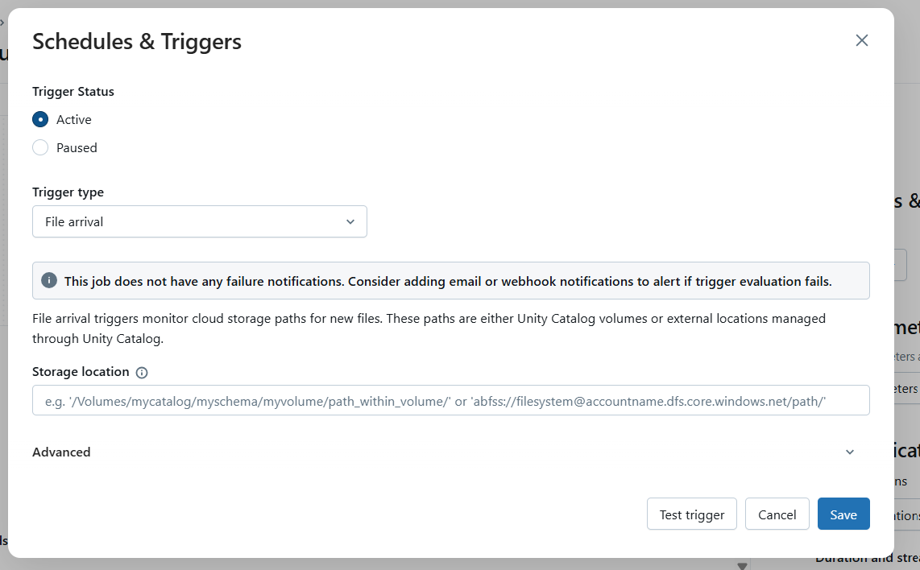

**Continuous**

**Job notifications**

**Add Notification**

**Permissions**

**Queue**

**Maximum concurrent runs**

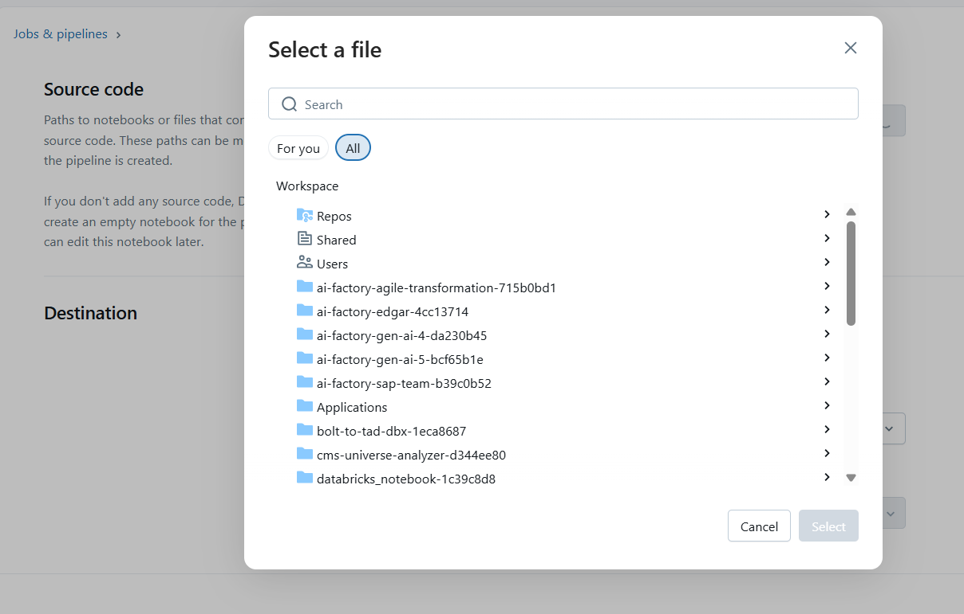

**Notifications**

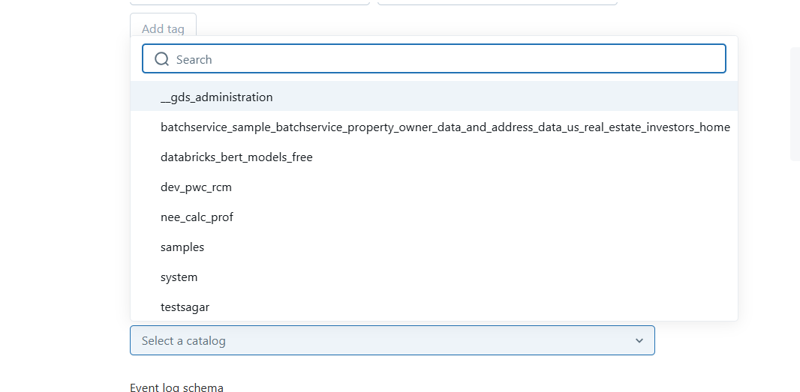

**Compute**

**Create new app**

